EXECUTIVE GAME THEORY CURRICULUM • 12-WEEK MASTER ARCHITECTURE
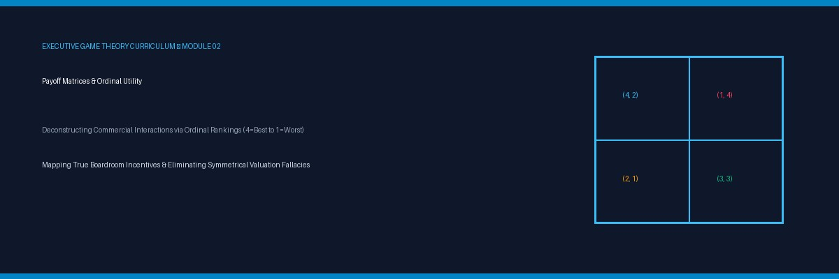

Lesson 02: Constructing Payoff Matrices & Ordinal Utility
Analytical Blueprint: Mapping Boardroom Outcomes through Ordinal Ranks (4=Best to 1=Worst) & Normal-Form Setup
Strategic Focus & Learning Objective: In this topic, we will be learning how to apply Ordinal Utility Scaling (4=Best, 1=Worst) and 2×2 Normal-Form Payoff Matrices to solve the False-Precision Valuation Fallacy (Financial Cardinality Paralysis in Joint Strategic Investments).
The Real-World Operational Problem: Executive leadership teams routinely delay, misprice, or paralyze strategic partnerships and capex allocations because FP&A models demand precise dollar projections (NPV, DCF, IRR) on competitor actions that cannot be quantified in advance. By demanding cardinal precision where only strategic direction exists, firms fall prey to 'precision paralysis'—allowing faster, directionally rational rivals to lock in core distribution channels.
How This Topic Solves It: Game-theoretic payoff matrices replace spurious cardinal cash flows with robust Ordinal Utilities (ranked 4 down to 1). By ordering outcomes across executive priorities (e.g., market independence, board survival, cash cushion, default avoidance), executives map the exact conditions under which agreements hold, defecting occurs, or mutual capital destruction is triggered—allowing definitive boardroom resolution in under ten minutes.
■ EXECUTIVE PEDAGOGICAL STANDARD
Decisions in strategic confrontations rarely require decimal-point forecasting. What matters is the relative ordering of outcomes: what an adversary would rather suffer before surrendering market position. When you know a competitor's ordinal hierarchy (their 4, 3, 2, 1), you know their exact tipping point.

Part I: The 4-Part Prelude Protocol
1. Models in Focus: The Ordinal Normal-Form Matrix, Symmetrical vs. Asymmetrical Payoff Scaling, and the Cardinality Paradox.
2. Lifelike Dilemma & Problem Statement: Two tier-1 pharmaceutical packaging manufacturers evaluate whether to invest $30M in cleanroom robotics. Vendor A calculates an NPV of +$8.4M if Vendor B abstains, but -$14.2M if Vendor B matches. Unable to forecast Vendor B's discount rate or labor capex, Vendor A's investment committee remains stalled for three quarters. Meanwhile, Vendor B—recognizing that failing to match cleanroom automation guarantees losing FDA tier-1 certification (Rank 1 = Worst)—moves forward decisively, capturing the sole vendor license.
3. Component Dissection: Vendor A suffered from Cardinality Paralysis. They attempted to model the rival's internal rate of return rather than evaluating the rival's ordinal priorities: Vendor B prioritized Regulatory Compliance Survival (Rank 4) over Short-Term Cash Preservation.
4. Lesson Embarkation: In this module, we formalize the construction of 2×2 normal-form payoff matrices using executive ordinal utility rankings.

Part II: The 7-Stage Core Pedagogy

Stage 1: Why Learn This (The 45-Second Operational Hook)
Financial spreadsheets provide cardinal numbers (dollars and cents) that create a dangerous illusion of certainty. But in competitive strategy, an opponent's choices are driven by ordinal utility—which outcome they prefer over another. Replacing uncertain cardinal calculations with ranked preferences (4, 3, 2, 1) eliminates boardroom paralysis and exposes your counterparty's dominant moves.
▼ CHECKPOINT: WHAT YOU MUST KNOW BEFORE MOVING FORWARD
Never ask 'How many dollars will the rival make?' First ask: 'Which outcome do they fear most, and which do they prioritize above all else?' Solve the ranking, and the strategic move becomes obvious.

Stage 2: The 5-Minute Core Framework (Matrix Construction & Ordinal Utility)
A normal-form game matrix organizes players, strategies, and payoffs into an actionable grid:
Player 1 \ Player 2 | Vendor B: Invest ($30M Capex) | Vendor B: Maintain Current Plant
Vendor A: Invest ($30M Capex) | (2, 2) [Mutual Capital Strain] | (4, 1) [A Dominates Market]
Vendor A: Maintain Current Plant | (1, 4) [B Dominates Market] | (3, 3) [Status Quo Cash Flow]

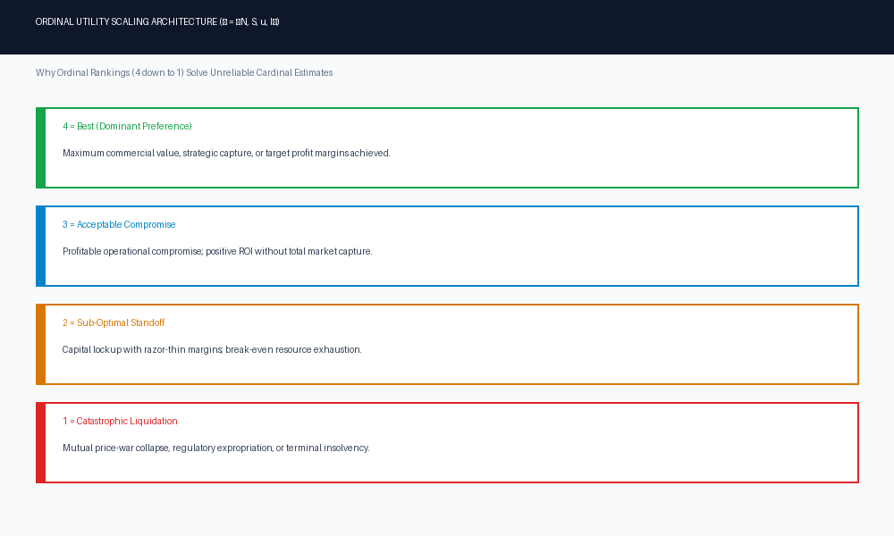
Figure 2A: The Ordinal Utility Scaling Architecture (4=Best down to 1=Worst)
▼ CHECKPOINT: WHAT YOU MUST KNOW BEFORE MOVING FORWARD
Every 2×2 payoff cell contains a pair (u1, u2). The first number belongs to Row Player 1; the second number belongs to Column Player 2. Always read the commas carefully.

Stage 3: The 3-Layered Operational Deep Dive
• Layer 1 — The Mechanical Protocol (The 4-to-1 Mapping Test): Rank every potential outcome for yourself from 4 (Optimal Blue Sky), 3 (Acceptable Baseline), 2 (Strained Compromise), to 1 (Catastrophic Loss). Repeat the exact ranking process for your counterparty based on their public liabilities and balance sheet posture.
• Layer 2 — The Cognitive Failure Mode (The Symmetrical Valuation Fallacy): Assuming that because you rank cash flow preservation as 4 (Best), your rival does too. If your rival is an unprofitable startup funded by aggressive venture capital, they may rank market share grab as 4 and cash burn as an acceptable 3.
• Layer 3 — Boundary Conditions: Ordinal matrices hold true under all positive monotonic transformations. Unlike cardinal NPV models which break if inflation shifts by 2%, ordinal matrices maintain stability under macroeconomic turbulence.
▼ CHECKPOINT: WHAT YOU MUST KNOW BEFORE MOVING FORWARD
Do not assume your competitors care about what you care about. A founder fighting for personal survival evaluates choices under completely different ordinal rankings than an institutional conglomerate.

Stage 4: Real-World Applications × 3
1. Commercial Manufacturing (Factory Capacity War): Two battery cell makers evaluate plant expansions in Europe. Both rank capturing EV contracts as 4, and losing battery supply mandates as 1.
2. Retail Distribution (Exclusive Brand Placement): A luxury cosmetic brand negotiates exclusivity with a department store chain; mapping ordinal priorities reveals that the department store values foot-traffic exclusivity (Rank 4) far higher than shelf-space fees.
3. Commercial Real Estate (Lease Renewal Standoff): An enterprise tenant threatens to vacate; the landlord ranks vacancy during high interest rates as 1 (Disaster), enabling the tenant to secure a 20% tenant improvement allowance.
▼ CHECKPOINT: WHAT YOU MUST KNOW BEFORE MOVING FORWARD
In every commercial negotiation, identify what outcome represents 1 (Disaster) for the counterparty. Leverage exists where their Rank 1 can be credibly triggered.

Stage 5: Diagnostic Self-Quiz & Evaluative Rubric
Scenario: Your enterprise software company is deciding whether to offer 24/7 dedicated engineering support. Your rival has twice your engineering headcount. If both offer 24/7 support, margins collapse (Rank 2 for both). If only your rival offers it, you lose enterprise renewals (Rank 1 for you). What is your rival's ordinal ranking for (Maintain Standard Support, Maintain Standard Support)?
A) (4, 4)
B) Rank 3 (Acceptable baseline margins, but missed expansion)
C) Rank 1
D) Unidentifiable without cost-accounting data.
Recommended Answer — B: For an incumbent with double your headcount, maintaining standard support provides safe baseline profitability (Rank 3), but they prefer unilateral 24/7 support (Rank 4) because their scale easily absorbs the labor overhead.
▼ CHECKPOINT: WHAT YOU MUST KNOW BEFORE MOVING FORWARD
Scale fundamentally alters ordinal rankings. High fixed-cost players prefer escalation battles that crush smaller, cash-sensitive rivals.

Stage 6: What You Should Know by Now (Daily Life Translation)
■ THE DAILY LIFE TRANSLATION
Ordinal utility is like ranking your weekend plans: 4 is going to your favorite concert; 3 is dinner with close friends; 2 is staying home doing laundry; 1 is food poisoning. You do not need a formula calculating 'happiness units' to know that staying home doing laundry (2) is strictly preferred to food poisoning (1). Make decisions on clear relative rankings, not decimal points.

▼ CHECKPOINT: WHAT YOU MUST KNOW BEFORE MOVING FORWARD
Relative preference is durable. Exact dollar calculations fluctuate daily; ordinal preferences endure across quarters.

Stage 7: Self-Regulated Practice & Interactive Discovery
Review the payoff matrix until you can instantly identify who holds the ordinal advantage in simultaneous interactions. Test your capability in the companion simulation engines below.

Topic 02 Companion Games: Operational Briefing & Deployment
1. Pedagogical Intent: Convert matrix construction and ordinal utility mapping into instinctive boardroom reflexes via twin interactive engines hosted on GitHub Pages.
2. Executive Objectives:
• Game 1 (Matrix Gridlock): Navigate dynamic 2×2 decision grids, harvesting ordinal utility tokens (4s and 3s) while evading Rank 1 trap tiles.
• Game 2 (Factory Capacity War Simulation): Manage capex allocations across 3 production cycles against an aggressive rival manufacturer.
3. Scoring Standards: Passing the calibration quiz in Game 1 activates a 200% Entry Buff. Game 2 carries DOUBLE WEIGHT (2x) on the unified leaderboard.
4. Playable Online Links:
• Game 1 (Matrix Gridlock): https://firedancerx.github.io/Game-Theory/Games/Lesson%2002/game1_matrix_gridlock.html
• Game 2 (Factory Capacity War): https://firedancerx.github.io/Game-Theory/Games/Lesson%2002/game2_factory_capacity_war.html
• Master Platform Portal: https://firedancerx.github.io/Game-Theory/

Appendix: Obsidian Knowledge Graph Semantic Triplets
Import these atomic triplets into your executive knowledge vault (Obsidian / Logseq):
%% Obsidian Raw Semantic Triplets (Copy & Paste into Vault) %%
[[Payoff Matrix]] --[formalizes]--> [[Normal-Form Representation]]
[[Ordinal Utility]] --[replaces]--> [[Spurious Cardinal Precision]]
[[Ordinal Rankings]] --[scales_from]--> [[4 (Best) to 1 (Worst)]]
[[Strategy Profile]] --[maps_to]--> [[Bimatrix Payoff Tuple]]
[[Symmetrical Fallacy]] --[assumes]--> [[Identical Utility Hierarchies]]
[[Asymmetric Utilities]] --[drives]--> [[Unexpected Strategic Collisions]]
[[Rank 1 Avoidance]] --[triggers]--> [[Credible Executive Leverage]]
Concept Entity | Historical Origin & Date | Obsidian Semantic Triplets | Executive Commercial Meaning
[[Payoff Matrix]] | Émile Borel (1921), John von Neumann (1928) | [[Payoff Matrix]] --[formalizes]--> [[Normal-Form Representation]] | A 2D coordinate grid mapping simultaneous strategy collisions and payoffs.
[[Ordinal Utility]] | Vilfredo Pareto (1906), Kenneth Arrow (1951) | [[Ordinal Utility]] --[replaces]--> [[Spurious Cardinal Precision]] | Evaluating choices by relative ranking (A preferred to B) rather than arbitrary dollar valuations.
[[Symmetrical Fallacy]] | Executive Decision Science Standard (2026) | [[Symmetrical Fallacy]] --[assumes]--> [[Identical Utility Hierarchies]] | The dangerous corporate error of projecting your own balance-sheet priorities onto a rival.

